PROCESS FOR SELF-RECORDING, FOOTAGE DELIVERY & DEADLINES
____________________________

TOP TIPS FOR SELF-FILMING
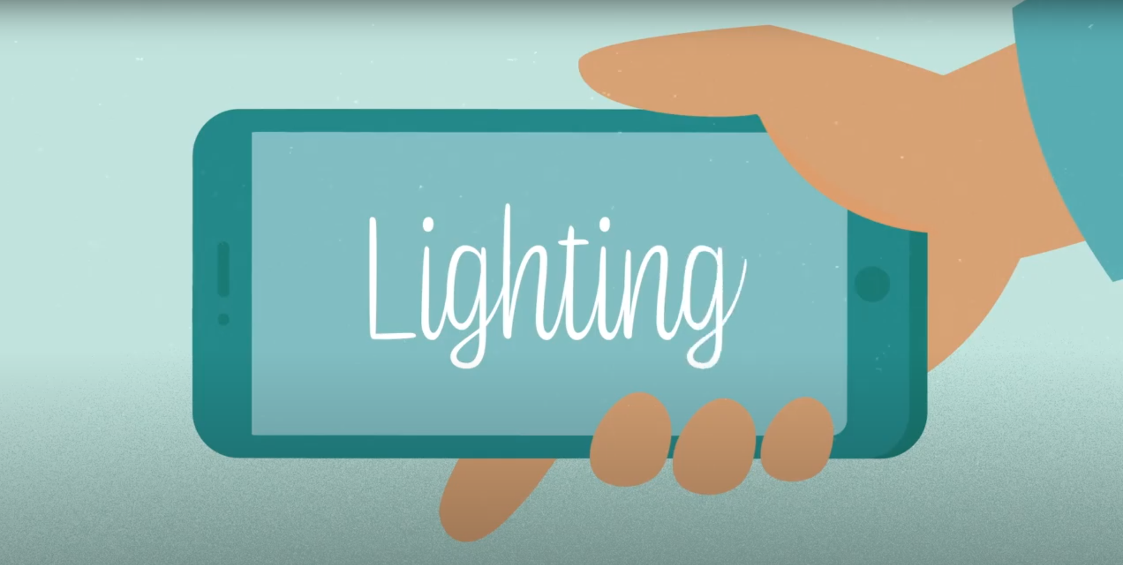 | - Find a nice bright space  - Make use of as much natural light as possible - if you can't use natural light, switch on a lamp.  - Don't film in a dark space, as it will be hard to see you  - And avoid filming in front of a window as it creates a silhouette effect around you.
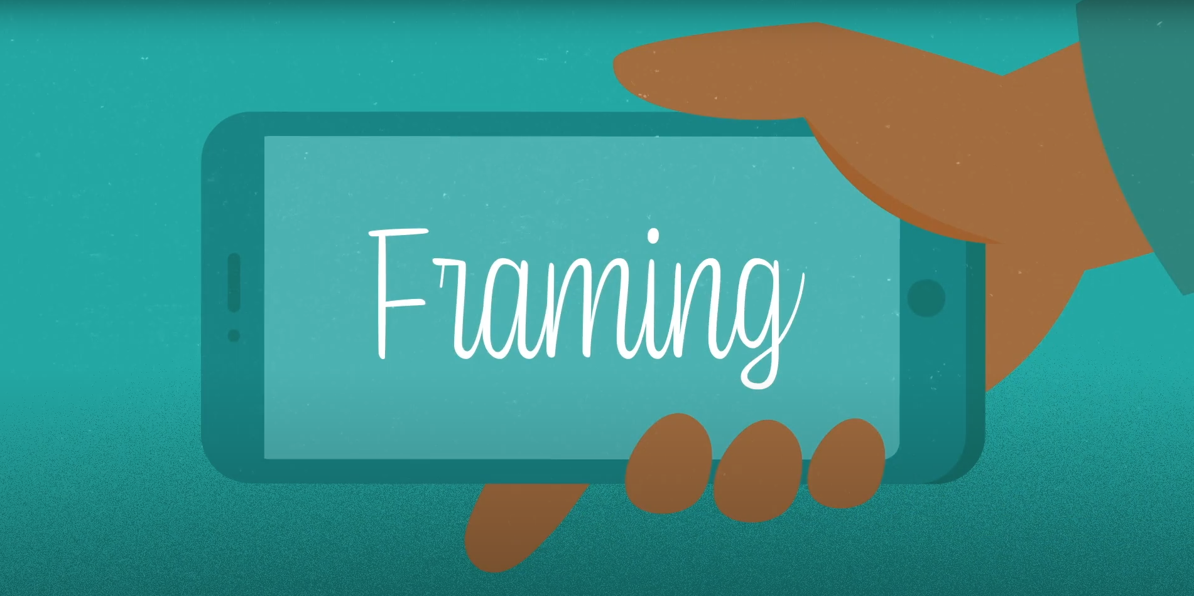 | - Put your device on selfie / shoot mode to find a nice spot  - You need to keep your device steady rather than holding it which can be jerky, so the classic option is to balance the device on some books or similar. You may even have a little tripod for your device - these don't cost much! We want it to feel as though you are recording on a laptop.  - Avoid filming in portrait mode as it leaves lots of dead space either side of the image. Please record in landscape.
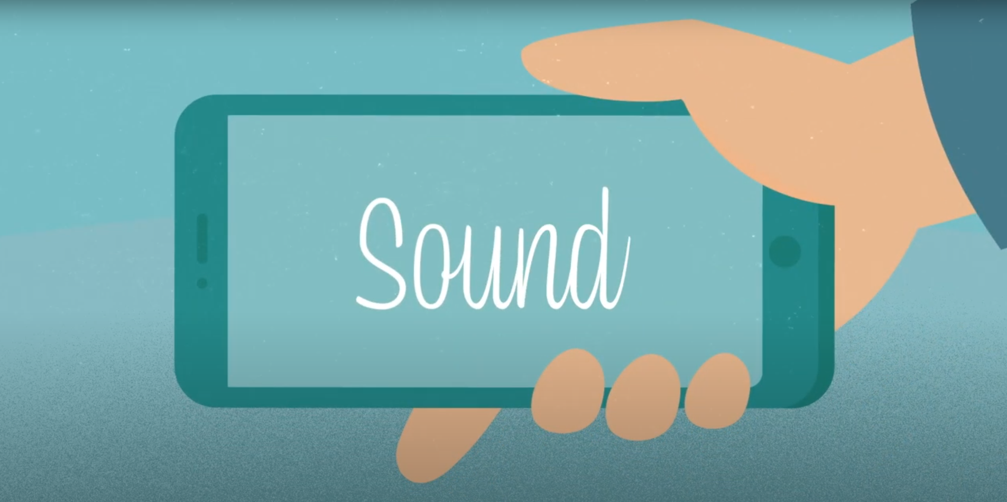 | - Film in a quiet space without much background noise
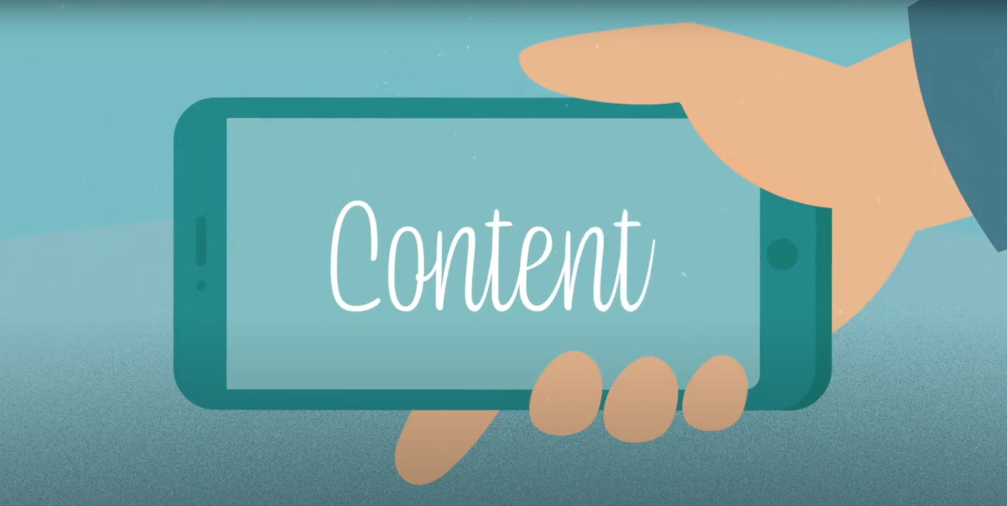 | - Keep it short and simple!

FOOTAGE DELIVERY

Dropbox
- Please upload all pupil’s self-recorded pieces to Speakers Trust Dropbox:
https://www.dropbox.com/request/ZBiidrzqaIFKEfhHqxpJ

Number of self-recorded pieces
- Please only send a maximum of 1 self-recorded speech per workshop (for example, if you receive 4 x Speaker Trust workshops for 4 classes, please only send 4 self-recorded speeches).

Labelling recordings for delivery
- Please be sure that each recording is clearly labelled with the student's name and school, to ensure a streamlined process when receiving everything (and no muddling of pupils' work with schools!).
- When using Dropbox, please use the comment box to detail what is being sent over, i.e. “5 recorded pieces by XX, XX, XX etc, from XX School (Teachers name)”.

NB: Please ensure you have collated all the relevant permissions for anyone who will appear on film.

DEADLINES
The self-recorded speeches do not need to be filmed on the day of the workshop, however in order for the recordings to be considered for the film, we need all self-recorded pieces to be sent to us by FRIDAY 28th MAY.
- Where possible, please do send the collection of self-recorded pieces within 4 weeks of your workshop, with absolute final delivery by Friday 28th May.

Anything received after this time, unfortunately will not be considered for the Celebration Film.

